CURRICULUM VITAE

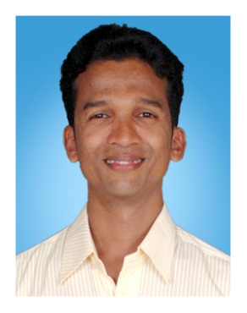
PRANAY CHANDRAKANT KORGAONKAR
R/o. Ubhadanda, Sukhatan Wadi,
Vengurla, Sindhudurga,
Maharashtra

Mob. : 09890740724
Email : korgaonkarpranav@gmail.com

Objective

To work for a good organization where I can achieve success, develop myself and worked betterment of the organisation.

STRENGTHS

- Honesty and Energetic
- Quick Learner
- Adaptability to changing environment
- Confident and hardworking
- Excellent Co-coordinating Capability

Personal Details

Name : Pranay Chandrakant Korgaonkar

Father’s Name : Chandrakant Korgaonkar

Date of Birth : 29th November 1986
Gender : Male
Nationality : Indian
Marital Status : Single

Educational qUAlification

- 2004: Completed S. S. C through Kolhapur Board in 48%
- 2006: Completed H. S.C. through Kolhapur Board in 52%

Additional qUAlification

- Computer Hardware Course, completed from MITCON -E-School

Work experience

- Worked in MicroSys as a Hardware Engineer from 2007 to 2012
- Presently working in Jamsons Computers Pvt. Ltd.

LANGUAGES KNOWN

English, Hindi, Marathi & Konkani

JOB RESPONSIBILITIES

- Hardware & Troubleshooting.
- Operating System Installation & configuration like Win95/Win98/Win XP/Win Vista/Win7/Win8/Win Server2K3/WinServer2008 etc.
- Software Installation like Ms-Office, Acrobat Reade 7.2, Photoshop, Antivirus, Hot Fix, Auto Cad etc.
- Troubleshooting and maintaining network Printers & other devices.
- Fault finding & troubleshooting of PC problems related to hardware and software.

(Pranay C. Korgaonkar)

